Intro to Django:

# Installing Django:

## Pre-requisites:

1. Install python 2.7
2. Set directory path (see important stuff.txt)
3. Install sqlite3: pip install sqlite3 (inside C:\Python27\Scripts)

## Instructions:

1. Open command prompt on location C:\Python27\Scripts (open location on windows explorer, press alt+d, type cmd and press enter)
2. Type – pip install Django==1.8.3 (or whatever version you wish)
3. Check installation by opening the python interactive shell (type python and press enter), and type import django. If no message is shown, it has installed properly.

# Creating a project:

1. Create a folder where you want your project files to be. Say: C:\Users\p077\Desktop\Projects\Python\Django Projects
2. Open the folder in command prompt and type the following
   1. django-admin startproject mysite
   2. cd mysite
   3. python manage.py migrate
   4. python manage.py runserver
3. You will get the following output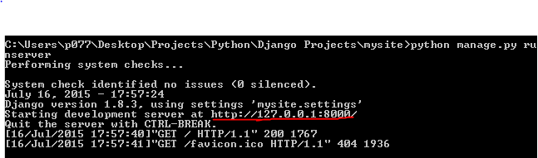
4. Copy paste the underlined part into a web browser. You should get the following output: 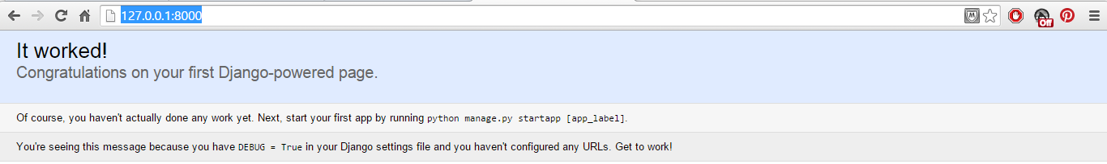
5. This indicates that everything has worked correctly so far.
6. Now, go on to command line again and type: “python manage.py syncdb”. You’ll get the following output: 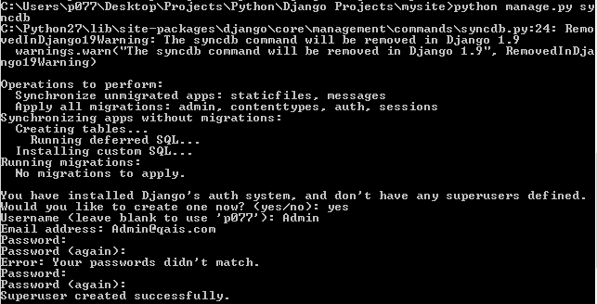
7. You will get a prompt to create a superuser. Type yes, set up a username and password, and continue.
8. Again, type: “python manage.py runserver” and open the url on a web browser. See 4.
9. Follow the url with “/admin”. You’ll get a login box. Type in the username and password you just set and continue.
10. And you are done with setting things up.